TEST CASES

The Best Results

- During the testing phase it was found that if the document was completely text embedded than the output would be exactly correct with near perfection.
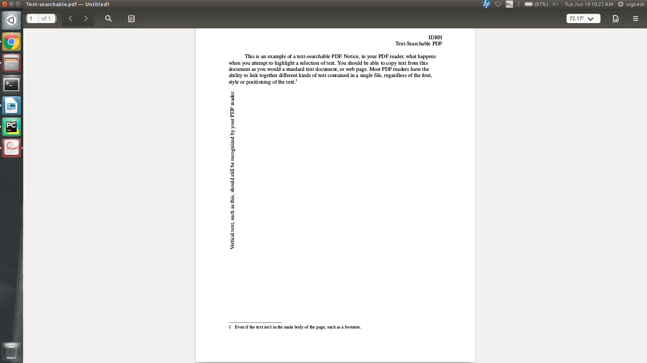

Output:

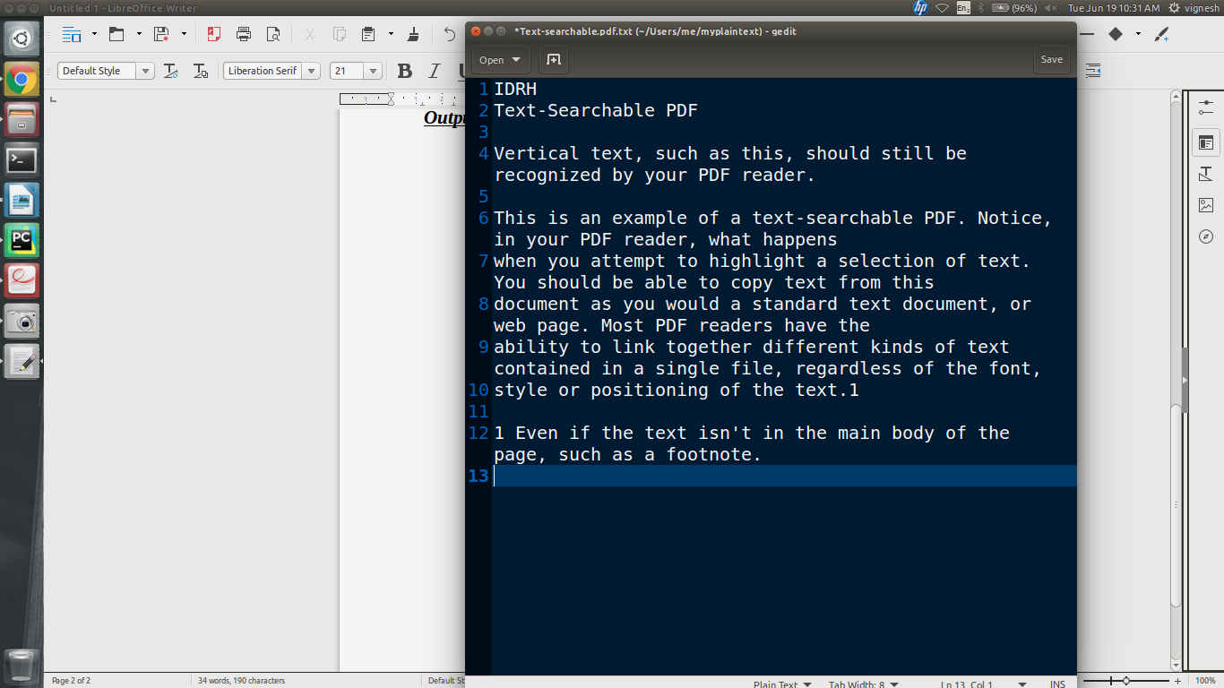
- As you can see the output is perfect. It even extracts horizontal and vertical lines and words placed in any position in the document.
- Also the text that is found in the footnotes and header/title part of the pdf is also extracted with high accuracy.
- The data is extracted with high accuracy irrespective of Font, Shape, Size, Color, or background.

Very Good Results
- It was found during the testing phase that the data that is not embedded is also quite accurately extracted except in certain exceptions.
- When directly embedded text is not available Tesseract OCR is performed with some preprocessing with the help of ImageMagick is used to efficiently extract the data.
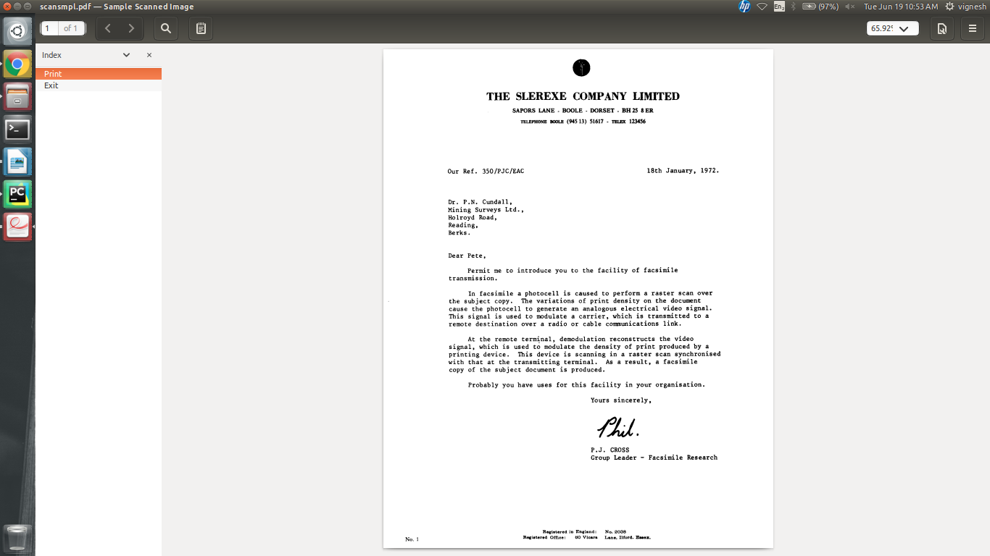
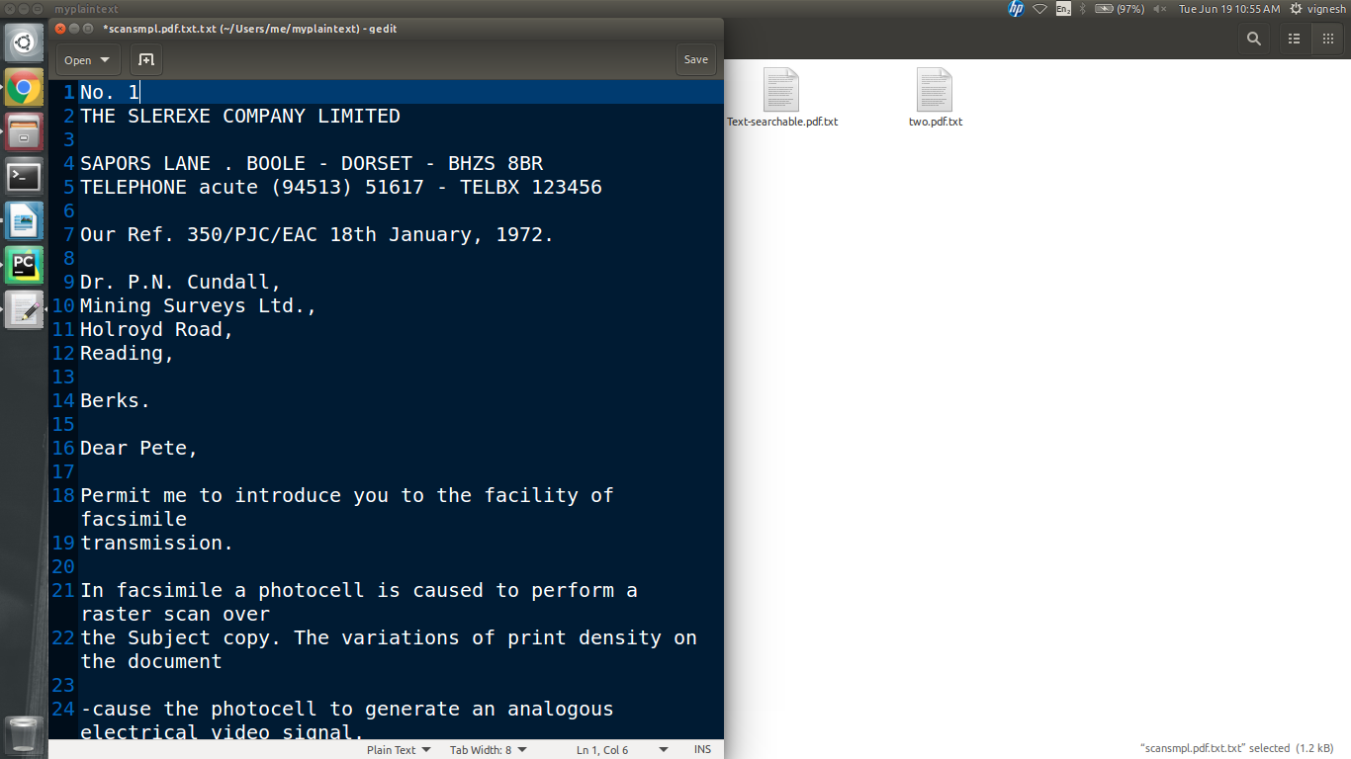
- As you can see the data is accurately extracted in spite of being a scanned pdf document.
- However the data may or may not be slightly rearranged due to the irregular formatting of the scanned image in the pdf.

The next case is when there images without any text in the document. In such cases the images are discarded and not considered for evaluation.

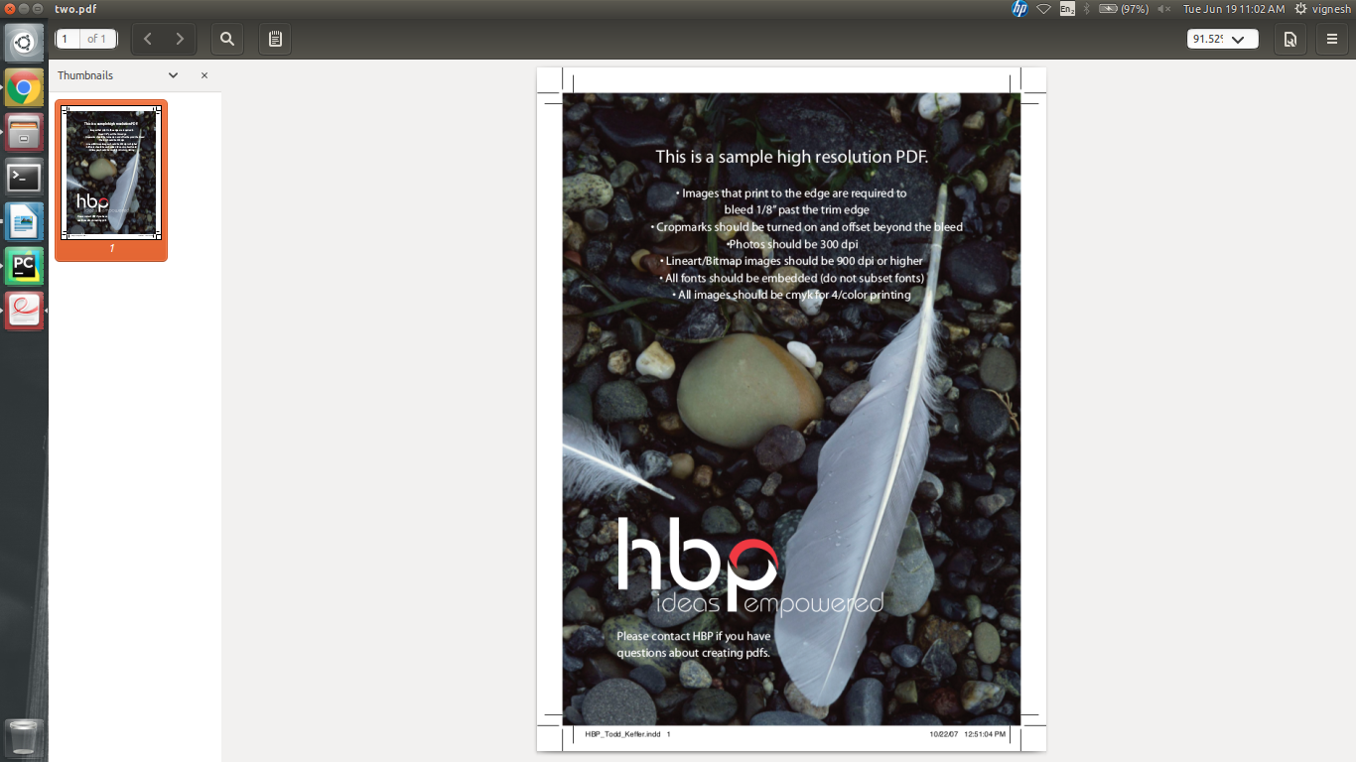

Output:
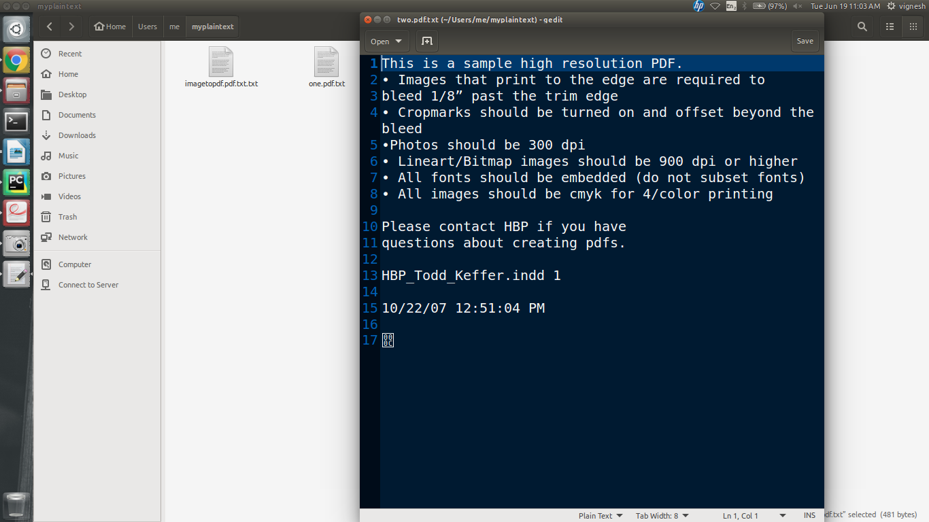
- It was found that highly fancy characters and logo images are not evaluated properly but a random symbol is placed as the script was not able to properly evaluate the picture.
- However the output is pretty accurate in spite of having a color background with high noise.

Average Results:
The lowest performance was found when the scanned pdf image is of very poor quality or if the text is present in an embedded image of an image in some natural setting.
However the script still tries to preprocess the data and filter out the data that is required and tries to extract it.

The following image is a scanned image of a screen-shot converted into a pdf.
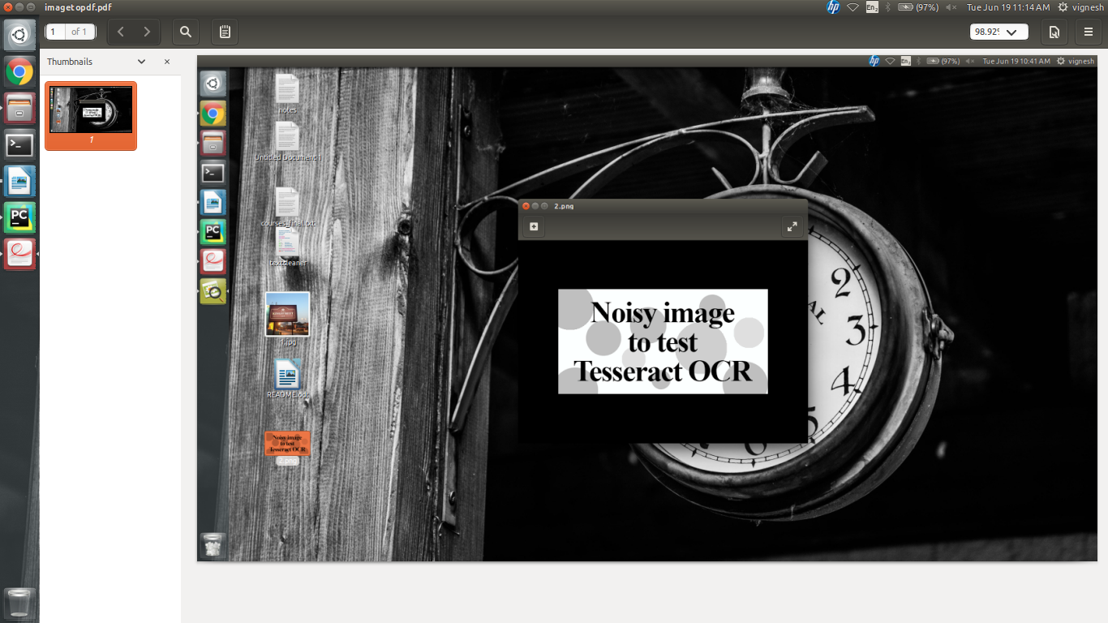

The above is a pdf containing a screen-shot containing some noisy text. The output is given below:
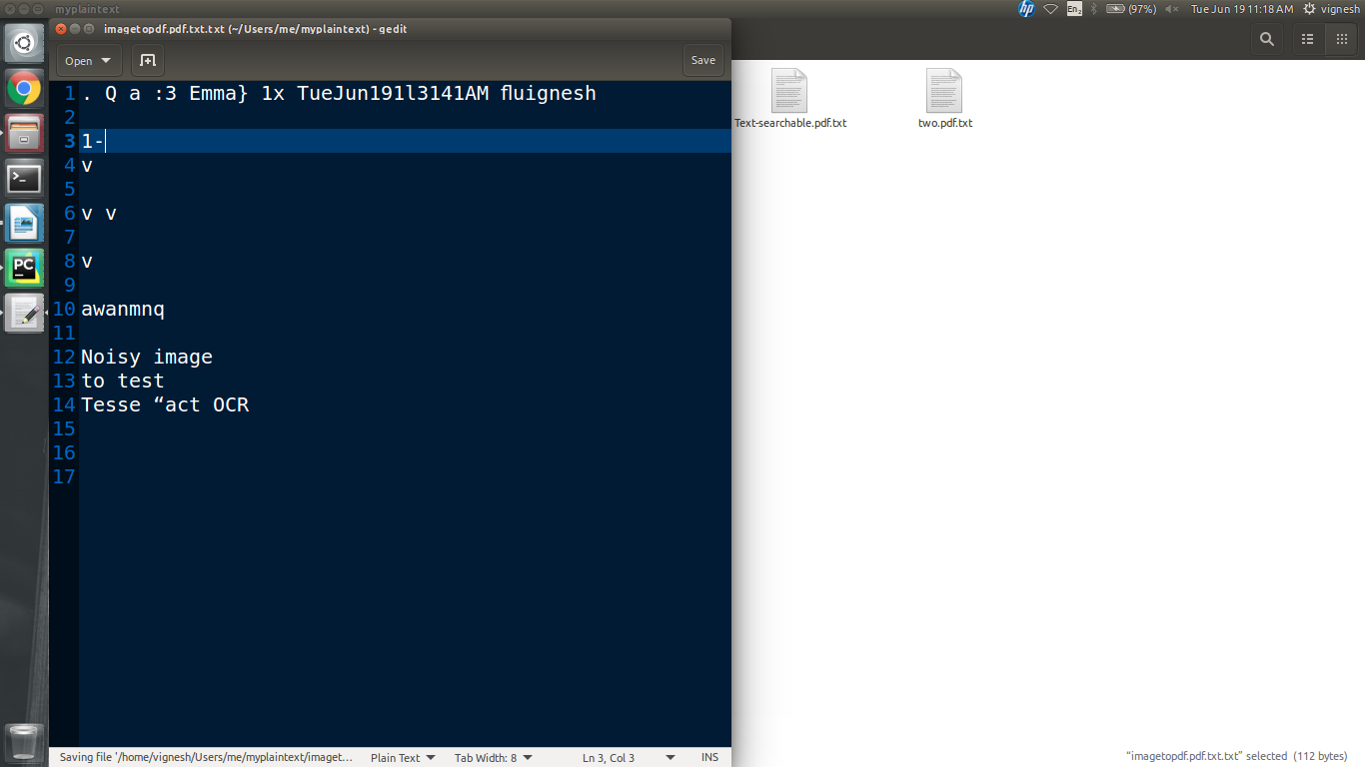

As you can see the data is still extracted but not accurately. However this is acceptable as pdf’s are rarely ever in such a format.

Input 2:
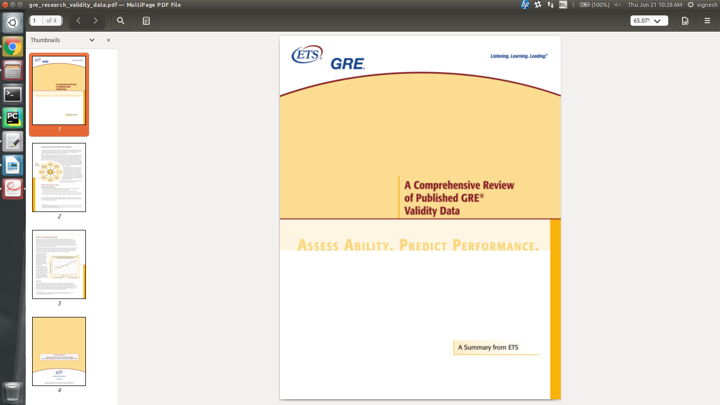
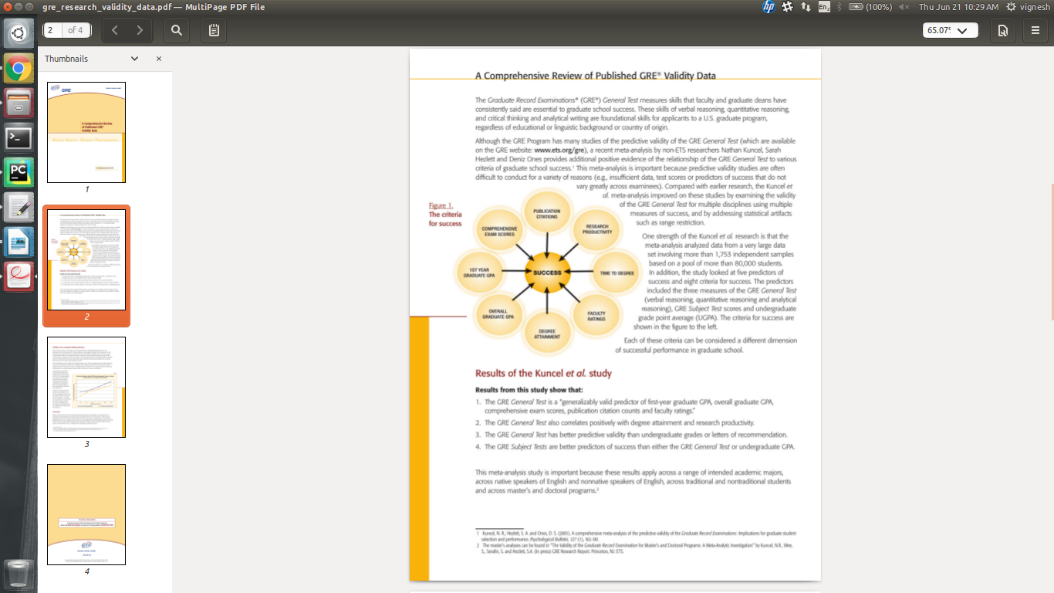

In the above cases it can be found that there is an above average conversion rate. The cases where the conversion failed to identify is the text where the the font color is almost identical to the background color.
But it can bee seen that even special characters such as the Registered Trademark ® is also correctly identified.
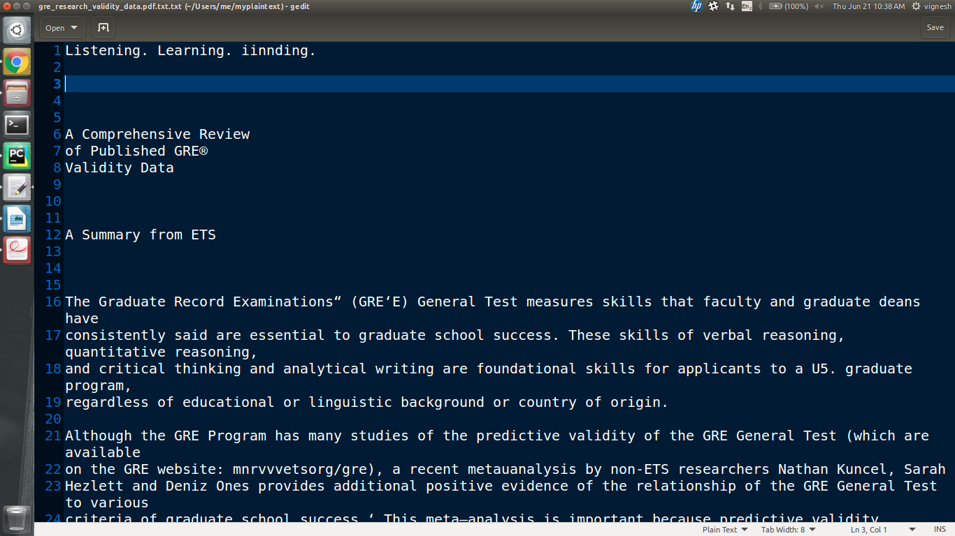
Output:
3.) The worst case scenario was usually found when trying to process a jpeg of a receipt taken by a hand held camera in a pdf format. The result is still readable but not very satisfactory.

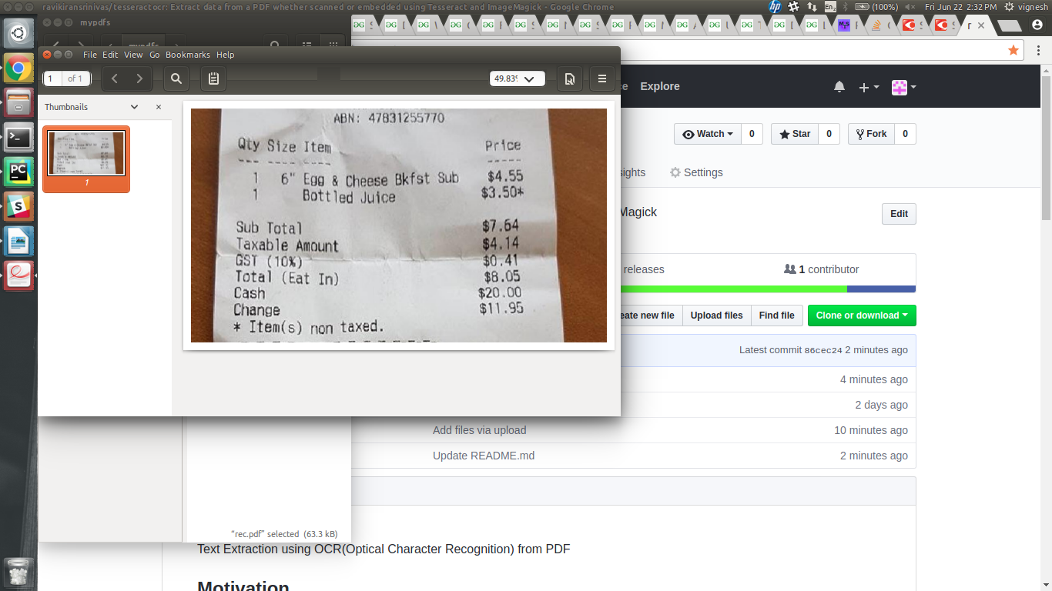
The output is given below:
